**Meeting Minutes [2]**

Date: 20 March 2021

Time: 18:00 PM to 22:30

Location:zoom

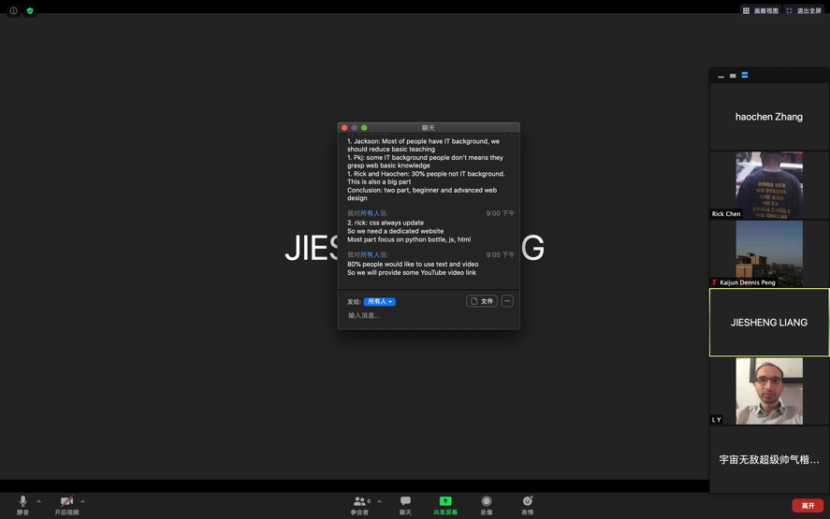

Members present:

* Jiesheng(Jackson) Liang
* Kaijun(Dennis) Peng
* Liu Yu
* Haochen zhang
* Bingyan chen

Agenda:

* Survey building
* Web ideas
* Task 3: web design and wireframe drawing
* Task 4: card sorting

|  |  |  |  |
| --- | --- | --- | --- |
| No. | Items | Presenter | Action by |
| 1. | Survey building  Everyone gives some ideas about what questions should be asked. | All the members | All the members |
| 2. | Web ideas  After we analyse our survey result, we make a discussion about which part we have to focus on. And what functions should our website included. | All the members | All the members |
| 3. | Task 3: web design and wireframe drawing  We talk about the each web pages design. Bingyan chen search some perfect website and we can gain some experience from others design. Liu Yu give some advice on which function each pages should have. And Haochen Zhang draw the wireframe and arrange the layout. | * Liu Yu * Haochen zhang * Bingyan chen | * Liu Yu * Haochen zhang * Bingyan chen |
| 4. | Task 4: card sorting  Jiesheng liang and kaijun peng design the card, and we find some people to do that. | * Jiesheng(Jackson) Liang * Kaijun(Dennis) Peng | * Liu Yu * Haochen zhang * Bingyan chen |
| 5 | Before next meeting:  Everyone will search some content and share the link on our google doc  Next meeting:  We will make our prototype by figma. | All the members | All the members |

Minutes prepared and recorded by: Haochen Zhang

Confirmed by: Kaijun(Dennis) Peng, Jiesheng(Jackson) Liang, Liu Yu, Haochen zhang